The Thrill of Performance
MOMENTUM Sport fuses the science of sport and sound
Wedemark, Germany, April 9th, 2024 – The Sennheiser brand today launches their all-new MOMENTUM Sport earbuds. Developed for athletes and sports enthusiasts, they combine state-of-the-art integrated heart rate and body temperature measurements in-ear sensors with unrivalled sound quality to elevate its users to new highs.
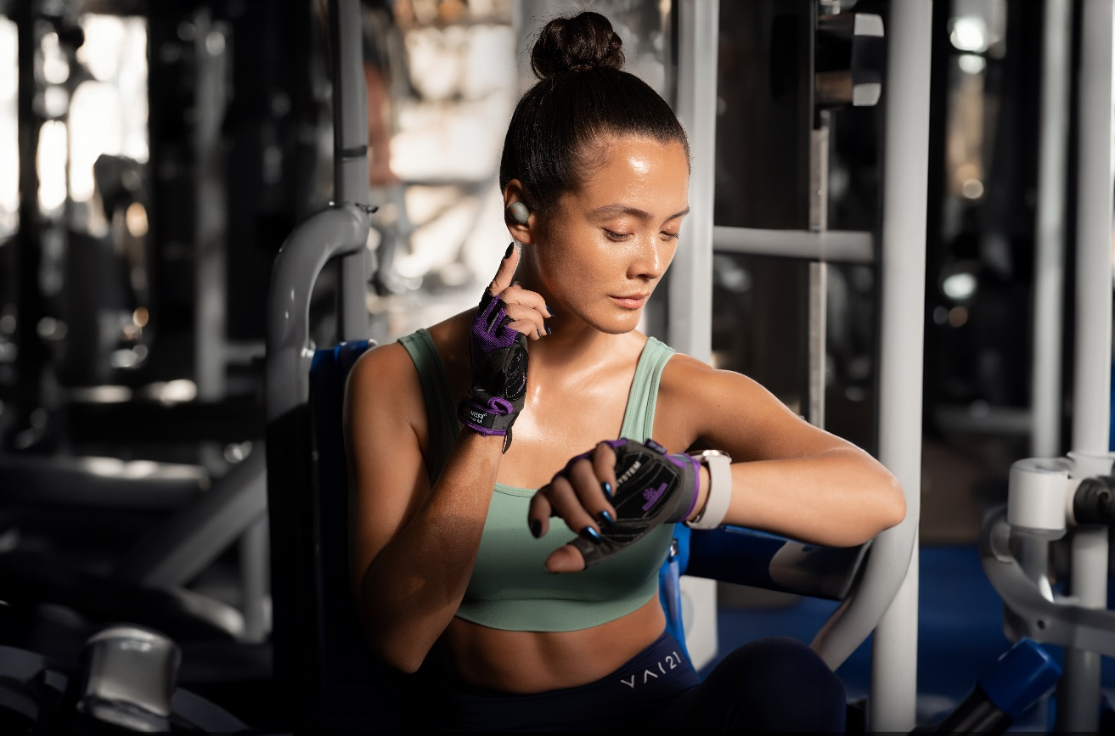
“We have worked for over three years to develop the ultimate sports earbuds, MOMENTUM Sport elevates earbuds from a basic exercise accessory to the heartbeat of your workout—quite literally,” says David Holm, Sennheiser Sports Product Manager, “Now, athletes and sports enthusiasts can tap into cutting-edge fitness tech and superb sound in one device.”
The rhythm of your heart
MOMENTUM Sport integrates both a photoplethysmography (PPG) heart rate sensor and a body temperature sensor that can each output critical data to popular fitness apps and devices. It’s no secret that the right playlist can make or break a workout—a high-energy soundtrack can motivate when the finish line feels impossibly far. Now, the power of Sennheiser Sound is optimized for sports and supercharged with real-time performance tracking data feedback for workouts that are far more efficient than a pure-adrenaline approach. As the inner ear is an optimal, dark location with a low degree of light pollution and is one of the most stable areas of the body during physical activity, MOMENTUM Sport can offer consistent performance tracking data, even at the peak of a workout.
In-ear temperature readings are also more accurate than wrist-skin measurements; the MOMENTUM Sport wearer can closely monitor their body temperature—within +/- 0.3 degrees Celsius accuracy—to avoid heat-related fatigue that could occur when exceeding the optimum target range for their workout. Similarly, the wearer can observe their heartrate with beats-per-minute detection ranging from 30 to 220 bpm—all while enjoying the raw motivational benefit of a great playlist. Integrated three-axis accelerometers plus capacitive touch and infrared sensors work in harmony to manage audio playback and call features using simple finger tap gestures, no matter the weather conditions. For example, a double-tap of the cheek can pause a track if the wearer is also using gloves.
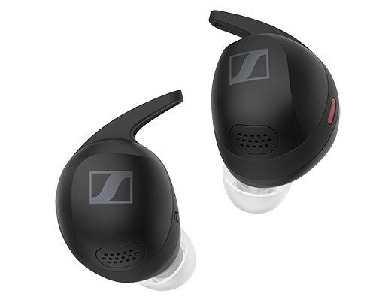

Polar Flow and fitness ecosystem integrations
MOMENTUM Sport’s heart rate data connects and integrates seamlessly with many popular sport devices and apps, such as Apple Watch/Health, Garmin Watch/Connect, Strava, Peloton and more. For the first time ever in a non-Polar product, users will now be able to enjoy full access to Polar’s elite biosensing capabilities and data analytics ecosystem by using Polar Flow as a training app. This includes access to expert-tier performance tracking, training analytics, smart coaching, and voice guidance. In-ear performance tracking data, including Body Temperature, are connected in real-time for instant insights during training and stored for enhanced post-training analysis in both the Polar Flow app and a desktop browser.

Upon release, MOMENTUM Sport will also have full integration of advanced performance tracking data in the Polar Vantage V3 multisport watch. Simply connect MOMENTUM Sport and start training to see real-time in-ear performance tracking data streaming directly to the watch. MOMENTUM Sport also supports Polar training audio and navigation guidance streaming directly to your ear during training.
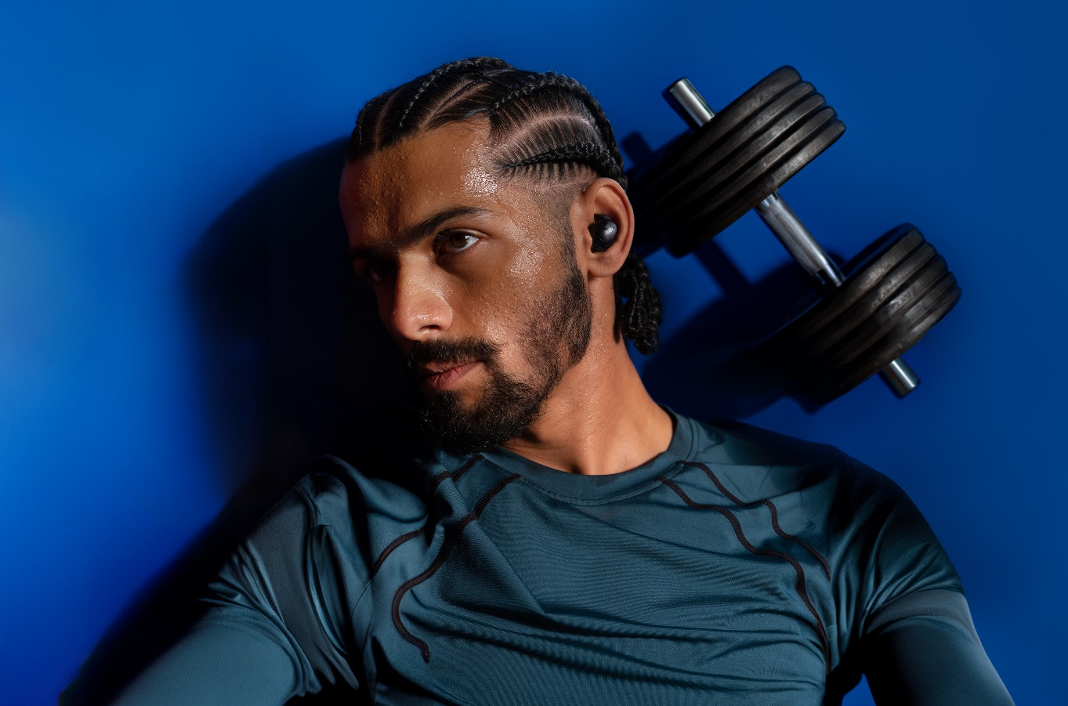
“Exercise and personal audio have been joined at the hip for as long as we can remember” notes Spiros Andreou, Business Product Manager from Polar, “The addition of biosensors and data output from a true wireless earbud with world-class acoustics is a natural progression that millions of athletes will find appealing to their fitness regimen. We’re proud to say our world-class and science-backed POLAR Flow ecosystem will support MOMENTUM Sport from day one.”

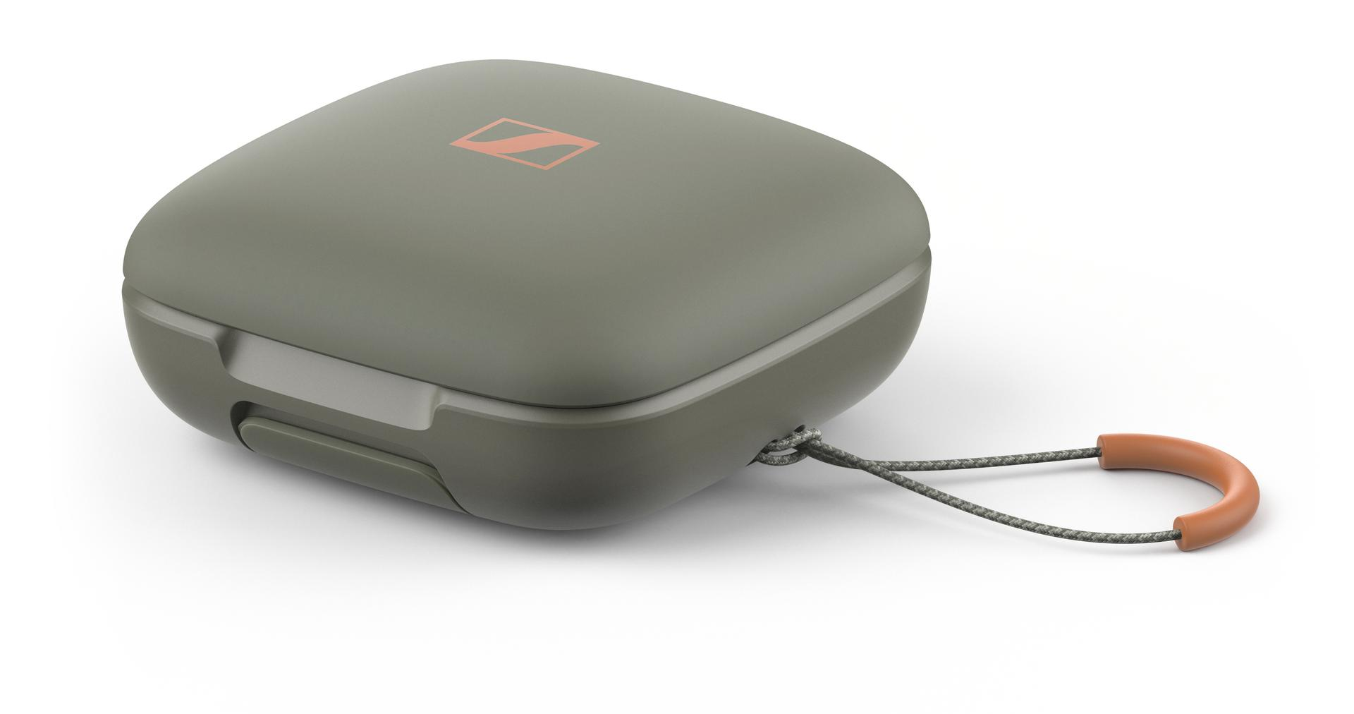
Hi-Fidelity Fitness
Sennheiser’s acoustics expertise goes beyond the all-new 10mm transducer found in MOMENTUM Sport. While vivid sound and impressive bass have been a prerequisite for Sennheiser sport headphones since they revolutionized the category in 2006, the needs of athletes and passionate sports enthusiasts required a complete reimagining of the acoustics system. Foremost, MOMENTUM Sport earbuds mitigate the occlusion effect with an acoustic relief channel that incorporates air ventilation. This dramatically minimizes footstep noise, breathing, and other body-borne distractions. The semi-open design also provides natural environmental awareness to stay alert to your surroundings, with additional and selectable Transparency mode, Anti-wind mode, and Adaptive Noise Cancelling mode so that the wearer can easily adjust as their surroundings change. MOMENTUM Sport operates over Bluetooth 5.2 with wide support for aptX Adaptive, AAC, and SBC codecs—not only do MOMENTUM Sport earbuds sound great on a rainy-day run or at the gym, but they also sound great on your commute, at home or wherever.

Ready for the fitness lifestyle
Sennheiser’s new sport earbuds can be controlled with the Sennheiser Smart Control App (iOS, Android) for the added convenience of an on-screen interface, however all essential features of MOMENTUM Sport can be controlled with simple tap gestures—a boon for those that wear protective gloves and ear warmers or perform actions that cannot spare nuance. Thanks to IP55 sweat & water resistance, a shock-proof chassis, and clog-resistant ear tips, MOMENTUM Sport are built to withstand the rigors of any workout—in or outdoors.
MOMENTUM Sport comes with a wide selection of interchangeable ear fins and ear tips for a personalized, secure fit that stays comfortable over prolonged training sessions. The larger transducer and corresponding housing are shaped to stay put even in medium to large-sized ears. The included robust IP54-rated carrying case stores up to three additional earbud recharges, extending the playback time from up to 6 hours to 24 total hours without reaching for a USB-C cable or Qi charging pad. And in a pinch, just 10 minutes of quick charging over USB can provide up to 45 minutes of playback on the go.
The MOMENTUM Sport is available now from sennheiser-hearing.com and selected Sennheiser retailers for an MSRP of $329.95 / €329.99. The earbuds come in three colorways; Polar Black, Burned Olive, and Metallic Graphite.

About the Sennheiser brand
We live and breathe audio. We are driven by the passion to create audio solutions that make a difference. Building the future of audio and bringing remarkable sound experiences to our customers – this is what the Sennheiser brand has represented for more than 75 years. While professional audio solutions such as microphones, meeting solutions, streaming technologies, and monitoring systems are part of the business of Sennheiser electronic GmbH & Co. KG, the business with consumer devices such as headphones, soundbars and speech-enhanced hearables became part of the Sonova Holding AG group of companies in 2022, who have licensed the Sennheiser trademark for this purpose.

www.sennheiser.com
www.sennheiser-hearing.com

Press contact
Sonova Consumer Hearing
Eric Palonen
PR and Influencers
Sennheiser Headphones and Soundbars
+1 (860) 908 1210
eric.palonen@sonova.com

